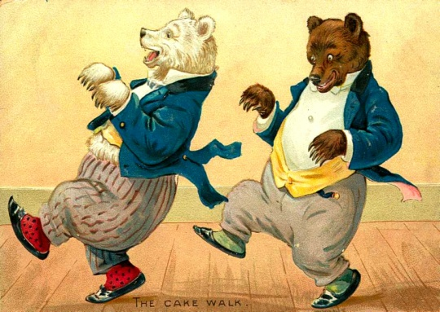
Laura Botsford Music
PO Box 422
Portland, Arkansas
71663
email:laurabotsford@yahoo.com
Phone: 501-733-6629

Fill in and email back to me please. laurabotsford@yahoo.com
Publisher: Laura Botsford
License use of song________________________________________
Licensed to: _____________________________________________
For personal use on website only and not to be resold or used in TV, Films or ad campaigns.
Date:____________________________________
Signature of Licensee: ________________________________
Signature of Publisher: _______________________________

